**1.1 DEFINITIONS OF AI**

The art of creating machines that perform functions that require intelligence performed by people (Kurzweil, 1990).

The branch of computer science that is concerned with the automation of intel behavior (Luger and Stublefield, 1993)

**1.2 Categorization of Intelligent System**

**Types of AI**

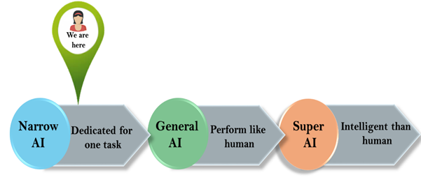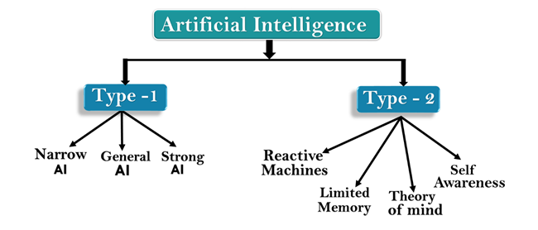

**Types of AI- Type 1**

**Weak AI or Narrow AI:**

* Narrow AI is a type of AI which is able to perform a dedicated task with intelligence. The most common and currently available AI is Narrow AI in the world of Artificial Intelligence.
* Narrow AI cannot perform beyond its field or limitations, as it is only trained for one specific task.

**General AI:**

* General AI is a type of intelligence which could perform any intellectual task with efficiency like a human.
* The idea behind the general AI to make such a system which could be smarter and think like a human by its own.

**Super AI:**

* Super AI is a level of Intelligence of Systems at which machines could surpass human intelligence, and can perform any task better than human with cognitive properties. It is an outcome of general AI.
* Some key characteristics of strong AI include capability include the ability to think, to reason, solve the puzzle, make judgments, plan, learn, and communicate by its own.

**Types of AI- Type 2**

**Reactive Machines:**

* Reactive AI systems do not store memories or past experiences for future actions.
* These machines only focus on current scenarios and react on it as per possible best action.

**Limited Memory:**

* Limited memory machines can store past experiences or some data for a short period of time.
* These machines can use stored data for a limited time period only.

**Theory of Mind:**

* Theory of Mind AI should understand the human emotions, people, beliefs, and be able to interact socially like humans.
* This type of AI machines are still not developed, but researchers are making lots of efforts and improvement for developing such AI machines.

**Self-Awareness:**

* Self-awareness AI is the future of Artificial Intelligence. These machines will be super intelligent, and will have their own consciousness, sentiments, and self-awareness.
* These machines will be smarter than human mind.

## **1.3 Components of AI**

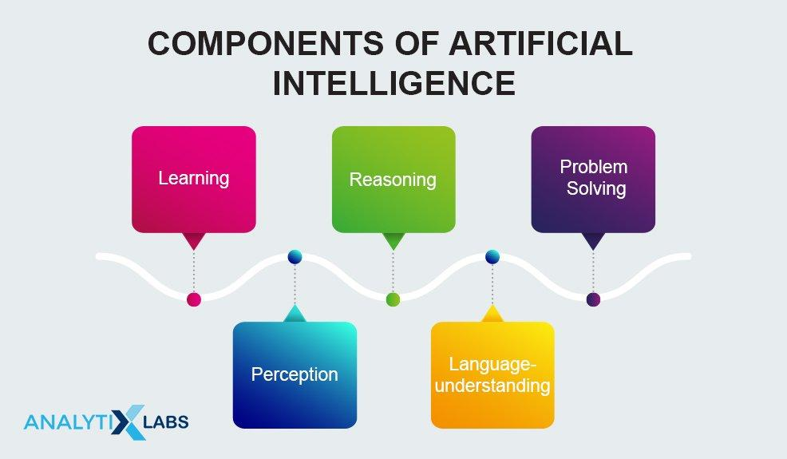

### **a.    Learning**

Similar to humans, computer programs also learn in different manners. Talking of AI, learning by this platform is further segregated into a varied number of forms. One of the essential **components of AI,**learning for AI includes the trial-and-error method. The solution keeps on solving problems until it comes across the right results. This way, the program keeps a note of all the moves that gave positive results and stores it in its database to use the next time the computer is given the same problem.

The learning component of AI includes memorizing individual items like different solutions to problems, vocabulary, foreign languages, etc., also known as rote learning. This learning method is later implemented using the generalization method.

### **b.    Reasoning**

The art of reasoning was something that was only limited to humans until five decades ago. The ability to differentiate makes Reasoning one of the essential **components of artificial intelligence.** To reason is to allow the platform to draw inferences that fit with the provided situation. Further, these inferences are also categorized as either inductive or deductive. The difference is that in an inferential case, the solution of a problem provides guarantees of conclusion. In contrast, in the inductive case, the accident is always a result of instrument failure.

The use of deductive interferences by programming computers has provided them with considerable success. However, reasoning always involves drawing relevant inferences from the situation at hand.

### **c.     Problem-solving**

In its general form, the AI’s problem-solving ability comprises data, where the solution needs to find x. AI witnesses a considerable variety of problems being addressed in the platform. The different methods of ‘Problem-solving’ count for essential **artificial intelligence components**that divide the queries into special and general purposes.

In the situation of a special-purpose method, the solution to a given problem is tailor-made, often exploiting some of the specific features provided in the case where a suggested problem is embedded. On the other hand, a general-purpose method implies a wide variety of vivid issues. Further, the problem-solving component in AI allows the programs to include step-by-step reduction of difference, given between any goal state and current state.

### **d.    Perception**

In using the ‘perception’ component of Artificial Intelligence, the element scans any given environment by using different sense-organs, either artificial or real. Further, the processes are maintained internally and allow the perceiver to analyze other scenes in suggested objects and understand their relationship and features. This analysis is often complicated as one, and similar items might pose considerable amounts of different appearances over different occasions, depending on the view of the suggested angle.

At its current state, perception is one of those **components of artificial intelligence**that can propel self-driving cars at moderate speeds. FREDDY was one of the robots at its earliest stage to use perception to recognize different objects and assemble different artifacts.

### e.    Language-understanding

In simpler terms, language can be defined as a set of different system signs that justify their means using convention. Occurring as one of the widely used **artificial intelligence components**, language understanding uses distinctive types of language over different forms of natural meaning, exemplified overstatements.

One of the essential characteristics of languages is humans’ English, allowing us to differentiate between different objects. Similarly, AI is developed in a manner that it can easily understand the most commonly used human language, English. This way, the platform allows the computers to understand the different computer programs executed over them easily.

# **1.4 Application of AI**

Artificial Intelligence has various applications in today's society. It is becoming essential for today's time because it can solve complex problems with an efficient way in multiple industries, such as Healthcare, entertainment, finance, education, etc. AI is making our daily life more comfortable and fast.

Following are some sectors which have the application of Artificial Intelligence:

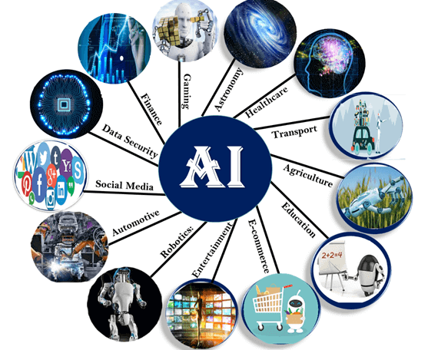

### **A. AI in Astronomy**

* Artificial Intelligence can be very useful to solve complex universe problems. AI technology can be helpful for understanding the universe such as how it works, origin, etc.

### **B. AI in Healthcare**

* In the last, five to ten years, AI becoming more advantageous for the healthcare industry and going to have a significant impact on this industry.
* Healthcare Industries are applying AI to make a better and faster diagnosis than humans. AI can help doctors with diagnoses and can inform when patients are worsening so that medical help can reach to the patient before hospitalization.

### **C. AI in Gaming**

* AI can be used for gaming purpose. The AI machines can play strategic games like chess, where the machine needs to think of a large number of possible places.

### **D. AI in Finance**

* AI and finance industries are the best matches for each other. The finance industry is implementing automation, chatbot, adaptive intelligence, algorithm trading, and machine learning into financial processes.

### **E. AI in Data Security**

* The security of data is crucial for every company and cyber-attacks are growing very rapidly in the digital world. AI can be used to make your data more safe and secure. Some examples such as AEG bot, AI2 Platform,are used to determine software bug and cyber-attacks in a better way.

### **F. AI in Social Media**

* Social Media sites such as Facebook, Twitter, and Snapchat contain billions of user profiles, which need to be stored and managed in a very efficient way. AI can organize and manage massive amounts of data. AI can analyze lots of data to identify the latest trends, hashtag, and requirement of different users.

### **G. AI in Travel & Transport**

* AI is becoming highly demanding for travel industries. AI is capable of doing various travel related works such as from making travel arrangement to suggesting the hotels, flights, and best routes to the customers. Travel industries are using AI-powered chatbots which can make human-like interaction with customers for better and fast response.

### **H. AI in Automotive Industry**

* Some Automotive industries are using AI to provide virtual assistant to their user for better performance. Such as Tesla has introduced TeslaBot, an intelligent virtual assistant.
* Various Industries are currently working for developing self-driven cars which can make your journey more safe and secure.

### **G. AI in Robotics:**

* Artificial Intelligence has a remarkable role in Robotics. Usually, general robots are programmed such that they can perform some repetitive task, but with the help of AI, we can create intelligent robots which can perform tasks with their own experiences without pre-programmed.
* Humanoid Robots are best examples for AI in robotics, recently the intelligent Humanoid robot named as Erica and Sophia has been developed which can talk and behave like humans.

### **H. AI in Entertainment**

* We are currently using some AI based applications in our daily life with some entertainment services such as Netflix or Amazon. With the help of ML/AI algorithms, these services show the recommendations for programs or shows.

### **I. AI in Agriculture**

* Agriculture is an area which requires various resources, labor, money, and time for best result. Now a day's agriculture is becoming digital, and AI is emerging in this field. Agriculture is applying AI as agriculture robotics, solid and crop monitoring, predictive analysis. AI in agriculture can be very helpful for farmers.

### **J. AI in E-commerce**

* AI is providing a competitive edge to the e-commerce industry, and it is becoming more demanding in the e-commerce business. AI is helping shoppers to discover associated products with recommended size, color, or even brand.

### **K. AI in education:**

* AI can automate grading so that the tutor can have more time to teach. AI chatbot can communicate with students as a teaching assistant.
* AI in the future can be work as a personal virtual tutor for students, which will be accessible easily at any time and any place.

**1.5 STATE SPACE REPRESENTATION**

A problem solving operator uses an operator which works to produce a new state in the knowledge base and is said to represent problems in a state space. In other words, a set of all possible states of a given problem is known as the state space of the problem. State space representation allows for the formal definition of a problem which necessitates the movement from a set of initial positions to one of a set of goal positions. This becomes clear from a simple day to day example of preparation of tea.

Suppose we are asked to prepare a cup of tea: what should be done? All the ingredients such as tea leaves milk powder, sugar, kettle, heating arrangement etc. must be made available

The following steps are needed

1 Boil requires a quantity of water.

2 Take some of the boiled water in a cup, add necessary amount of tea leaves to make decoction (extraction of flavor by boiling).

3. Add milk powder to some boiling water to make milk

4 Mix decoction and milk.

5. Add sugar to your taste

6. Tea is prepared

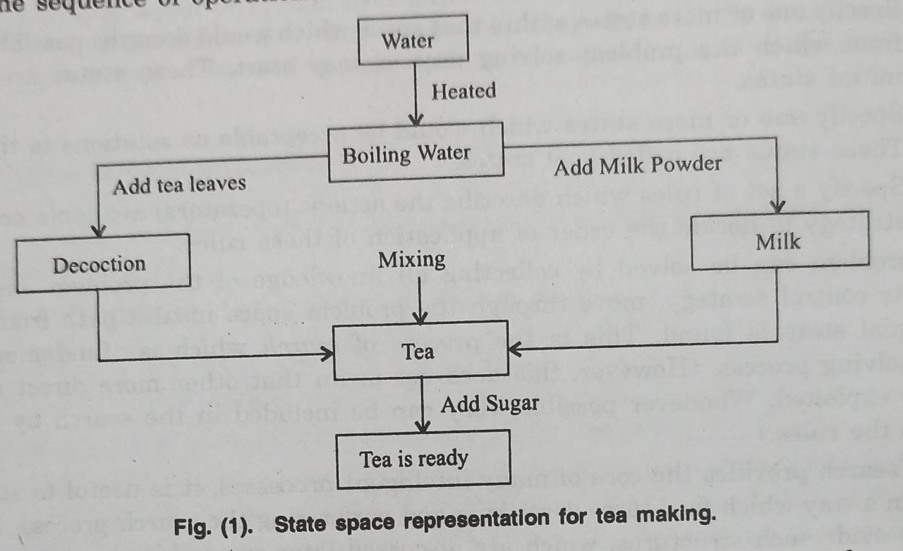

Now think a bit about what has exactly happened We started with the ingredients (initial state), followed a sequence of steps (called states) and at last had a cup of tea (goal state). We added only needed amount of tea leaves, milk powder and sugar (operators). Fig (1) shows the sequence of operations

This combination of all possible states for a given problem is known as the state space of the problem

This example illustrates that the system's task is to find a path between two specified states in the state space, i.e., the initial state and a specified goal This concept can be expanded to a puzzle and its solution, the axioms and a theorem to be proved etc. It can be shown that problem solving, planning, learning, scientific discovery, mathematical theorem proving etc. are all essentially search problems. We do a lot of work in AI in detailed reduction of such problems to search problems

Three Basic Components of an Implicit State Space Representation

1. A description with which to label a start node This description is some data structure modeling the initial state of the (agent's) environment.

2. Functions which transform a state description representing one state of the environment into one that represents the state that results after an action. These functions are usually called operators. They are models of the effects of actions When an operator is applied to a node it generates one of the node's successors.

3. A goal condition, which can be either True-False valued function on a state description or a list of actual instances of state descriptions that correspond to goal states

**1.6 Agents in Artificial Intelligence**

An AI system can be defined as the study of the rational agent and its environment. The agents sense the environment through sensors and act on their environment through actuators. An AI agent can have mental properties such as knowledge, belief, intention, etc.

**What is an Agent?**

An agent can be anything that perceive its environment through sensors and act upon that environment through actuators. An Agent runs in the cycle of **perceiving**, **thinking**, and **acting**. An agent can be:

* **Human-Agent:** A human agent has eyes, ears, and other organs which work for sensors and hand, legs, vocal tract work for actuators.
* **Robotic Agent:** A robotic agent can have cameras, infrared range finder, NLP for sensors and various motors for actuators.
* **Software Agent:** Software agent can have keystrokes, file contents as sensory input and act on those inputs and display output on the screen.

Hence the world around us is full of agents such as thermostat, cellphone, camera, and even we are also agents.

Before moving forward, we should first know about sensors, effectors, and actuators.

**Sensor:** Sensor is a device which detects the change in the environment and sends the information to other electronic devices. An agent observes its environment through sensors.

**Actuators:** Actuators are the component of machines that converts energy into motion. The actuators are only responsible for moving and controlling a system. An actuator can be an electric motor, gears, rails, etc.

**Effectors:** Effectors are the devices which affect the environment. Effectors can be legs, wheels, arms, fingers, wings, fins, and display screen.

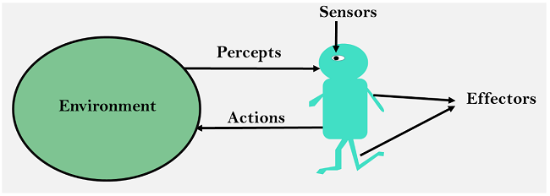

## **Intelligent Agents:**

An intelligent agent is an autonomous entity which act upon an environment using sensors and actuators for achieving goals. An intelligent agent may learn from the environment to achieve their goals. A thermostat is an example of an intelligent agent.

Following are the main four rules for an AI agent:

* **Rule 1:** An AI agent must have the ability to perceive the environment.
* **Rule 2:** The observation must be used to make decisions.
* **Rule 3:** Decision should result in an action.
* **Rule 4:** The action taken by an AI agent must be a rational action.

## **Rational Agent:**

A rational agent is an agent which has clear preference, models uncertainty, and acts in a way to maximize its performance measure with all possible actions.

A rational agent is said to perform the right things. AI is about creating rational agents to use for game theory and decision theory for various real-world scenarios.

For an AI agent, the rational action is most important because in AI reinforcement learning algorithm, for each best possible action, agent gets the positive reward and for each wrong action, an agent gets a negative reward.

### **Rationality:**

The rationality of an agent is measured by its performance measure. Rationality can be judged on the basis of following points:

* Performance measure which defines the success criterion.
* Agent prior knowledge of its environment.
* Best possible actions that an agent can perform.
* The sequence of percepts.

## **Structure of an AI Agent**

The task of AI is to design an agent program which implements the agent function. The structure of an intelligent agent is a combination of architecture and agent program. It can be viewed as:

Agent = Architecture + Agent program

Following are the main three terms involved in the structure of an AI agent:

**Architecture:** Architecture is machinery that an AI agent executes on.

**Agent Function:** Agent function is used to map a percept to an action.

f: P* → A

**Agent program:** Agent program is an implementation of agent function. An agent program executes on the physical architecture to produce function f.

## **PEAS Representation**

PEAS is a type of model on which an AI agent works upon. When we define an AI agent or rational agent, then we can group its properties under PEAS representation model. It is made up of four words:

* **P:** Performance measure
* **E:** Environment
* **A:** Actuators
* **S:** Sensors

Here performance measure is the objective for the success of an agent's behavior.

### **PEAS for self-driving cars:**

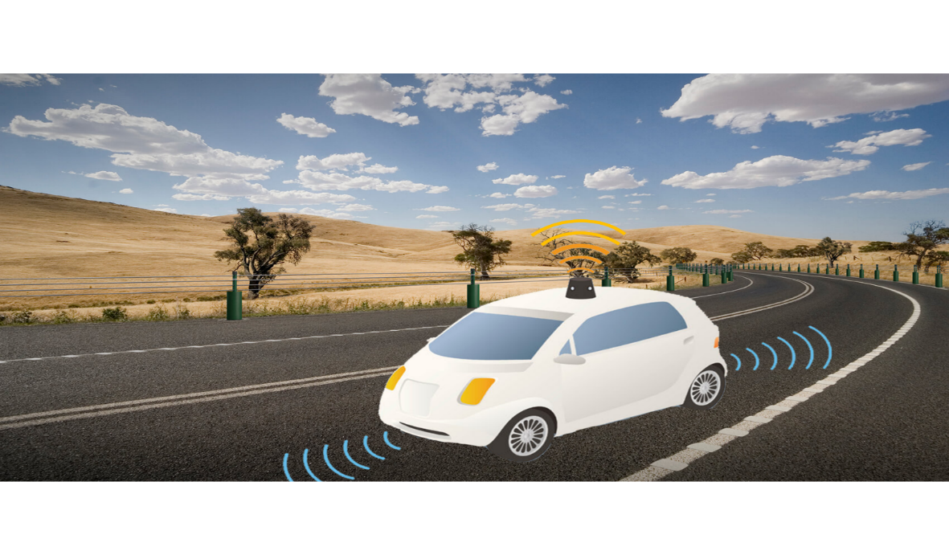

Let's suppose a self-driving car then PEAS representation will be:

**Performance:** Safety, time, legal drive, comfort

**Environment:** Roads, other vehicles, road signs, pedestrian

**Actuators:** Steering, accelerator, brake, signal, horn

**Sensors:** Camera, GPS, speedometer, odometer, accelerometer, sonar.

## **Example of Agents with their PEAS representation**

|  |  |  |  |  |
| --- | --- | --- | --- | --- |
| **Agent** | **Performance measure** | **Environment** | **Actuators** | **Sensors** |
| **1. Medical Diagnose** | * Healthy patient * Minimized cost | * Patient * Hospital * Staff | * Tests * Treatments | Keyboard (Entry of symptoms) |
| **2. Vacuum Cleaner** | * Cleanness * Efficiency * Battery life * Security | * Room * Table * Wood floor * Carpet * Various obstacles | * Wheels * Brushes * Vacuum Extractor | * Camera * Dirt detection sensor * Cliff sensor * Bump Sensor * Infrared Wall Sensor |
| **3. Part -picking Robot** | * Percentage of parts in correct bins. | * Conveyor belt with parts, * Bins | * Jointed Arms * Hand | * Camera * Joint angle sensors. |

## **1.7 Advantages and Disadvantages of AI**

**Advantages:**

* + More powerful and more useful computers
  + New and improved interfaces
  + Solving new problems
  + Better handling of information
  + Relieves information overload
  + Conversion of information into knowledge

**Disadvantages:**

* + Increased costs
  + Difficulty with software development - slow and expensive
  + Few experienced programmers
  + Few practical products have reached the market as yet.